
Technical report XX/YYYY
Prague, year
Authors: Main author 1, Main author 2, team
NAME OF THE REPORT

REPORT NAME: Enter the name of the report
PROJECT NAME: Enter the name of the project
PROJECT IDENTIFICATION:
Final, Ongoing report – delete as required
CONTRACT NUMBER: SO YYYY - XX
Bibliographical report:
RESEARCHERS:
Institution 1¹, Institution 2², Institution 3³
TEAM OF AUTHORS: Author 1¹, Author 2³ (format for author names – Surname F.)
The superscripts after the authors' names refer to the list of institutions above.

First name Surname  Project manager (SÚRAO)  DD/MM/YYYY | First name Surname  Project manager (the contractor's institution)  DD/MM/YYYY

Content
1 Heading 1 SÚRAO. Level "Heading 1" 2
1.1 Heading 2 SÚRAO. Level "Heading 2" 2
1.1.1 SÚRAO Heading 3. Level "Heading 3" 2
2 Equations 6

List of Annexes:
The "List of Annexes" heading is formatted as a SÚRAO heading, i.e. Arial Bold font, size 14 pt, dark green SÚRAO – RGB (0,102,53), CMYK (91,12,92,44). The indent before paragraphs is 18 pt.
Reference Examples:
The "Reference Examples" heading is formatted as SÚRAO Normal bold, i.e. Arial Bold font, size 11 pt, black. The indent before paragraphs is 10 pt.

List of abbreviations:
DGR deep geological repository
NPP nuclear power plant
FDC spent fuel disposal canister
Explanation of terms:
Concrete container
A concrete container is a spent fuel disposal container approved for the deposition of radioactive waste unacceptable for near-surface or deep repositories.
Safety function
The safety function refers to operations of the system, structure, components, or another part of the nuclear equipment that are important for ensuring nuclear safety of the nuclear equipment.

Abstract
The "Abstract" heading is formatted as a SÚRAO heading, i.e. Arial Bold font, size 14 pt, dark green SÚRAO – RGB (0,102,53), CMYK (91,12,92,44). The indent before paragraphs is 18 pt. The regular text is formatted as Normal SÚRAO Arial font, size 11 pt, black. Justified. Line spacing is 1.15; the indent before paragraphs is 6 pt, after paragraphs 8 pt.
The abstract should briefly characterise the entire work in a maximum of one page, ideally half a page.
Keywords
Deep geological repository, bentonite, hydraulic conductivity
Abstract
The "Abstract" heading is formatted as a SÚRAO heading, i.e. Arial Bold font, size 14 pt, dark green SÚRAO – RGB (0,102,53), CMYK (91,12,92,44). The indent before paragraphs is 18 pt. The regular text is formatted as Normal SÚRAO Arial font, size 11 pt, black. Justified. Line spacing is 1.15; the indent before paragraphs is 6 pt, after paragraphs 8 pt.
The abstract should briefly characterise the entire work in a maximum of one page, ideally half a page.
Keywords
Deep geological repository, bentonite, hydraulic conductivity

Heading 1 SÚRAO. Level "Heading 1"
Heading 1 SÚRAO is Arial Bold font, size 17 pt, dark green SÚRAO – RGB (0,102,53), CMYK (91,12,92,44). Heading 1 SÚRAO is always on a new page. Only 5 heading levels are allowed. The levels of headings 1–5, the styles of Heading 1 SÚRAO, Heading 2 SÚRAO, and Heading 3 SÚRAO are numbered.
The regular text is formatted as Normal SÚRAO Arial font, size 11 pt, black. Justified. Line spacing is 1.15; the indent before paragraphs is 6 pt, after paragraphs 8 pt. Pages are numbered in the bottom centre, font size 10 pt.
Move prepositions about, from, with, in, and to from the end of the line to the beginning of a new line, much like conjunctions and and as well as. The preferred method of doing so is by inserting a fixed space using Ctrl+Shift+Space.
Hyphenating words at the end of a line is not permitted.

Heading 2 SÚRAO. Level "Heading 2"
Font Arial Bold, size 15 pt, dark green SÚRAO – RGB (0,102,53), CMYK (91,12,92,44). Only 5 heading levels are allowed. The levels of headings 1–5, the styles of Heading 1 SÚRAO, Heading 2 SÚRAO, and Heading 3 SÚRAO are numbered.

SÚRAO Heading 3. Level "Heading 3"
Font Arial Bold, size 13 pt, dark green SÚRAO – RGB (0,102,53), CMYK (91,12,92,44). Only 5 heading levels are allowed. The levels of headings 1–5, the styles of Heading 1 SÚRAO, Heading 2 SÚRAO, and Heading 3 SÚRAO are numbered.
Bullets
Use the default Microsoft Word indents on the "Home" tab, "Paragraph" group, "Bullets" button.
- Example
- Example
- Example
Normal SÚRAO text
The regular text is formatted as Normal SÚRAO Arial font, size 11 pt, black. Justified. Line spacing is 1.15; the indent before paragraphs is 6 pt, after paragraphs 8 pt.
Reference to Fig. 1 . A reference to a picture is inserted using a cross reference. On the "Insert" tab, click the "Cross-reference" button. Choose that you want to reference the Type reference "Picture" and choose the picture to which you want to refer. In the box, select that you want to reference "To label and number only".

SÚRAO Heading 4 Level "Heading 4"
Font Arial Bold, size 12 pt, dark green SÚRAO – RGB (0,102,53), CMYK (91,12,92,44). Only 5 heading levels are allowed. The levels of headings 1–5, the styles of Heading 1 SÚRAO, Heading 2 SÚRAO, and Heading 3 SÚRAO are numbered.

SÚRAO Heading 5 Level "Heading 5"
Font Arial Bold, size 11 pt, dark green SÚRAO – RGB (0,102,53), CMYK (91,12,92,44). Only 5 heading levels are allowed. The levels of headings 1–5, the styles of Heading 1 SÚRAO, Heading 2 SÚRAO, and Heading 3 SÚRAO are numbered.
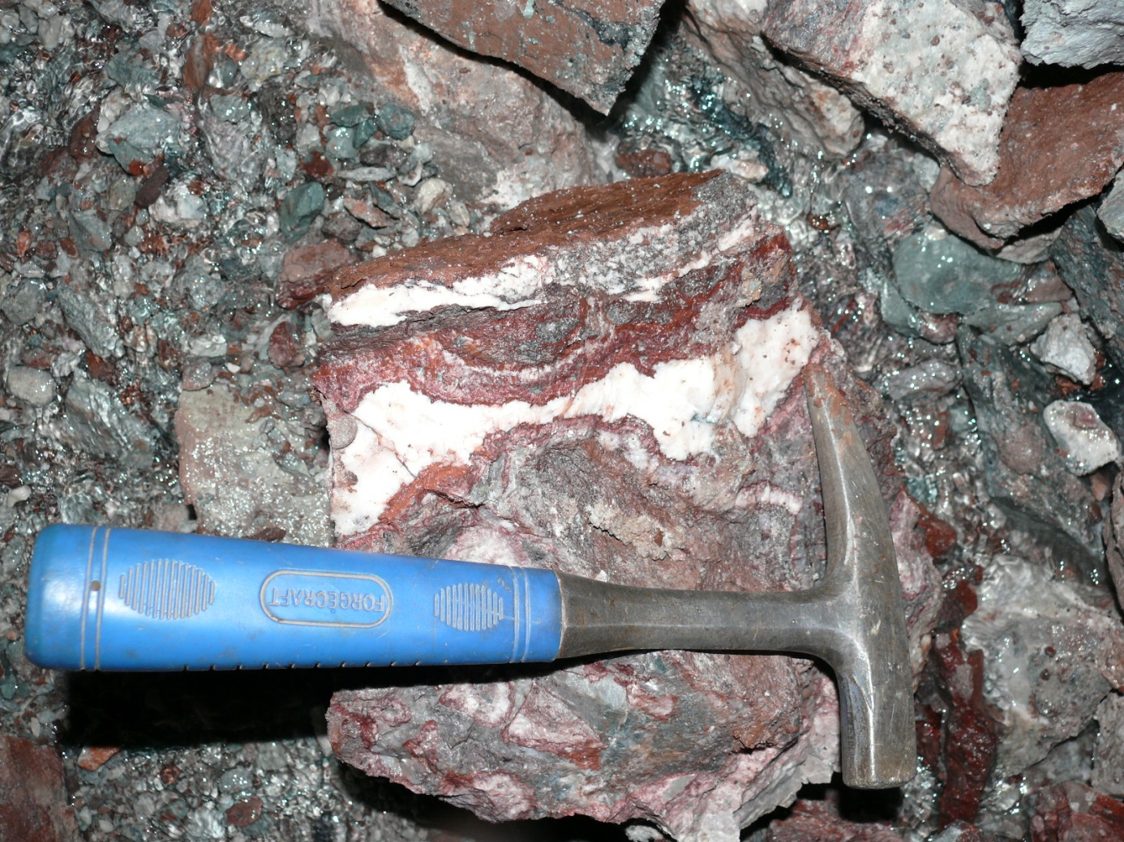
Fig. 1 Carbonate filler of the fracture zone
The SÚRAO Fig. heading is formatted as Arial font, size 10, italic. Descriptions of figures must only be added using cross references (using the "Reference" tab in the "Captions" group, press the "Insert caption" button and choose a suitable caption). When using this function for the first time, first click the "New caption" button in the "Caption" window and create the necessary captions – Picture, Table, Chapter. Then it is not necessary to create the captions, but only to choose the suitable caption in the "Caption" box. The caption is located below the picture. Style of the caption: Caption.
Reference to Tab. 1. A reference to a table is inserted using a cross reference. On the "Insert" tab, click the "Cross-reference" button. Choose that you want to reference the Type reference "Table" and choose the table to which you want to refer. In the box, select that you want to reference "To label and number only".
Tab. 1 PÚ Horka coordinates
peak number | X coordinate | Y coordinate | peak number | X coordinate | Y coordinate
1 |  |  | 8
2 |  |  | 9
3 |  |  | 10
4 |  |  | 11
5 |  |  | 12
6 |  |  | 13
7 |  |  | 14
Keep the format of the table for the bordering, the font style, and the repeated headings on the following page.
Caption of the table: The SÚRAO heading is formatted as Arial font, size 10 pt, italic. Descriptions of tables must only be added using cross references (using the "Reference" tab in the "Captions" group, press the "Insert caption" button and choose a suitable caption). When using this function for the first time, first click the "New caption" button in the "Caption" window and create the necessary captions – Picture, Table, Chapter. Then it is not necessary to create the captions, but only to choose the suitable caption in the "Caption" box. The caption of the table is located below the picture. Style of the caption: SÚRAO heading.
Citations and bibliography
Citations of the authors' names are written in the text; two authors are separated by "and", e.g. Krásný and Dudek (2000). In cases with multiple authors, the first author is followed by "et al.". Two or more citations are separated by semicolons (Vrána 2005, 2008, 2009; Verner 2010). Each cited author must be included in the bibliography.
References in the bibliography are formatted in the "SÚRAO References" style; see the practical examples below. References are written in the following way: the author and name of the work (followed by a full stop) are separated by a dash with spaces. A reference is always followed by a full stop. The authors' surnames are separated by a comma behind the initial of the first name, and the publication date is written in brackets, followed by a colon; for example: Krásný J., Dudek A. (2000): If a book or map has an editor (editors), they are referred to by ed. (eds), regardless of whether it is a Czech or foreign publication.

Specific types of references:
- a collection/periodical: the full title or a form of established abbreviations (nouns are written with initial capital letters), comma, the year, comma, volume number, comma, page range. The location of issue is not written for periodicals unless it is part of an established abbreviation. For example: Sbor. Geol. Věd, Antropozoikum, 1, 75–100. Sbor. St. geol. Úst., 2, 1, 5–16. Zpr. Geol. Výzk. v Roce 1960, 34–36. Chem. Geol. (Amsterdam), 48, 43–55. Amer. Mineralogist, 71, 1297–1313. [But: Beneš J. (1981): Soupis československých geologických periodik. – Ústř. úst. Geol. Praha.]
- a book: the author, publication date (in brackets), colon, name of the book, full stop, number of pages, full stop, dash (with spaces), publisher, full stop, location of issue. For example: Taylor S. R., McLennan S. M. (1981): The continental crust: Its composition and evolution. 312 p. – Blackwell. Oxford. If the book has an editor (editors) and is cited as a whole, only the editors' names are stated. For example: James K., Petera P. eds (1991): Light Scattering. – Random House Ltd. Washington. ISBN:
- a lecture or poster at a conference: the name of the conference (congress, symposium) is written in the original language, then the date and place of the event. For example: CzechTec 07 – 5th Meeting of the Central European Tectonic Studies Group (CETeG) & 12th Meeting of the Czech Tectonic Studies Group (ČTS), April 11–14, 2007, Teplá, Czech Republic. Proceedings and excursion guide, 90–91. – Čes. geol. služ., Praha. ISBN:
- a manuscript: the MS abbreviation is used. For example: Tvrdý V. (1971): Litomyšlsko 5120332237. Surovina cihly. GP Jihlava. – MS Čes. geol. Služ. – Geofond. Praha. Zpráva o provedení průzkumného vrtu v areálu závodu 06 KAROSA – Polička, okres Svitavy. – MS Vodní zdroje. Bylany.
Sedlák J., Zabadal S., Gnojek I., Rejl L. (2017): Třebíčský masiv – tíhové řezy. – Technická zpráva 127/2017, MS SÚRAO, Praha.

Equations
Equations are set on a separate line and numbered. Their numbers are put in brackets and serve as easy references in the text. All symbols, variables, and functions must be described immediately following the equation.
Each equation is a part of the sentence; therefore, it must be incorporated in it as in the following examples.
Insert the equation using the "Insert" tab and the "Equation" button in the "Symbols" group. The numbering of an equation is inserted using the "Insert" tab. In the "Text" group, click the "Quick parts" button and the "Field" button in the box. In the dialogue window, choose in the "Category: Numbering" box and the "SEQ" type. In the "Code fields", write the EQ behind the SEQ and confirm with "OK". Add round brackets around the number.
If you want to refer to an equation using a cross reference in the text, first you have to insert a bookmark to the equation. You can enter the bookmark using the "Bookmark" button in the "References" group, "Insert" tab. Write the tab heading "Equation1" in the "Bookmark" dialogue window and click "Add". If you need to refer to the bookmark in the text, click "Cross-reference" in the "References" group on the "Insert" tab. In the "Cross-reference" dialogue window, choose "Reference type: Bookmark" and the bookmark in the "For bookmark" field to which you want to refer. In the "Insert reference to" box, choose "Text of the bookmark" and click "Insert".
One-dimensional discrete cosine transform is defined by the formula (1)
, (1)
Where f(x) is a signal in the time area, F(u) is its transformed image, γ(u) represents the weight coefficient, the index takes a value from 0 to N-1, and the N constant determines the number of points in the input signal.
Therefore, the corresponding formula will be followed with a comma or a full stop as necessary. Potential numbering of the formula is seen as a supplementary graphic symbol, which does not belong in the flow of the text (thus, no punctuation symbols are written there).
The variables in the text of the equation and the actual text are always in italics and the constant values always in normal font. Indexes of all quantities are always written in normal font.
The formula is set on a separate line and centred; important formulas are numbered (see an example below). The numbering adopts the number of the chapter and behind the full stop, there is the sequence number of the formula in the given chapter (numbering of sections or further itemization is not adopted; i.e. numbering such as 3.1.1 is not used)
. (2)
In a formula such as (2), which represents the least squares estimation function, the matrices and the vectors are written in bold; transposition (if we mark it with letter "T") should be normal font, analogous to all names of the customary functions (logarithm, etc.). All other letters are written in italics, numbers in normal font. Let us show two more examples of formulas with indexes and customary functions:
, (3)
. (4)
If the work derives a formula by gradual modification over several lines, the "=" symbols are aligned under each other as in the following example, which derives the scatter of parameters of a linear regression model using the least squares method:
(5)

References
Books, articles, maps, chapters:
The "Books, articles, maps, chapters" heading is formatted as SÚRAO Normal Bold, i.e. Arial Bold, size 11 pt, black. Align left. Line spacing is 1.15; the indent before paragraphs is 6 pt, after paragraphs 8 pt.
Aftalion M., Bowes D.R., Vrána, S. (1989): Early Carboniferous U-Pb zircon age for garnetiferous, perpotassic granulites, Blanský les massif, Czechoslovakia. – N. Jb. Miner., Mh. 1989, 145–152.
Anděra M., Zavřel P. (2003): Šumava – příroda, historie, život. – Miloš Uhlíř-Baset Publishers. ISBN 978-80-7075-779-6.
Babůrek J., Pertoldová J., Verner K., Jiřička J. (2006): Průvodce geologií Šumavy. – Správa NP a CHKO Šumava, ČGS Praha.
Balatka B., Kalvoda J. (2006): Geomorfologické členění reliéfu Čech. – Kartografie Praha a.s., 79 p, 3 maps, Praha.
Barnet I. (2001): Mapa radonového indexu geologického podloží 1: 50 000, sheet 32-14 Nová Pec. Czech Geological Survey Praha.
Berger A., Kalt A. (1999): Structures and Melt Fractions as Indicators of Rheology in Cordierite-Bearing Migmatites of the Bayerische Wald (Variscan Belt, Germany). J. Petrology, 40, 11, 1699–719.
Brabec J. (1970): Zpráva o průzkumu rašelinných ložisek v kraji Západočeském. – MS Expediční skupina pro průzkum půd, Praha –Suchdol, Čes. Akad. Zemědělská.
Brandmayr M., Dallmeyer R. D., Handler R., Wallbrecher E. (1995): Conjugate shear zones in the Southern Bohemian Massif (Austria): implications for Variscan and Alpine tectonothermal activity. – Tectonophysics, 248, 97–116.
Laws:
The "Laws:" heading is formatted as SÚRAO Normal bold, i.e. Arial Bold, size 11 pt, black. Align left. Line spacing is 1.15; the indent before paragraphs is 6 pt, after paragraphs 8 pt.
Act No 183/2006 Coll., on spatial planning and construction rules (the Building Act) as amended.
Act No 183/2006 Coll., as amended.
Act No 137/2006 Coll., on public contracts, Article 2, paragraph 3, letter a, point 2, paragraph 3, letter a, point 2 – (if there is no reference to Article 4, paragraph 2 or Articles 7 through 11 in the citation).
Technical standards:
ČSN EN ISO 94 88 (ČSN 73 0300). Solar energy – Dictionary. Prague: Czech Institute for Standards, Metrology and Testing. 2001. 44 p.
Website:
Subduction. Wikipedia. [Online]. 10-03-2015 [cit. 2015-03-10]. Available at: http://cs.wikipedia.org/wiki/Subdukce

Appendix 1



